M3. Assignment 3.3 Rossler Gian Karlo Boquiren

Step 2

Q1.

What query would you run to list the first and last names of the 5 customers who have the highest number(count) of payments? You can title the number of payments as num_payments.

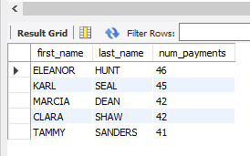

Q2.

What query would you run to get the customer_id associated with all payments greater than twice the average payment amount? (HINT: use 2 * in your query to get twice the amount). Your result should include the customer id and the amount.

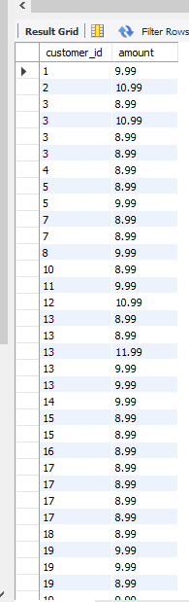

Q3.

What is the distribution of animals based on their age categories? Categorize the animals into 'Young,' 'Adult,' and 'Senior' based on the following criteria:

* 'Young' if the age is up to 7 years,
* 'Adult' if the age is between 8 and 9 years,
* 'Senior' if the age is 10 years or older, except for turtles, which are considered 'Young' up to 20 years.

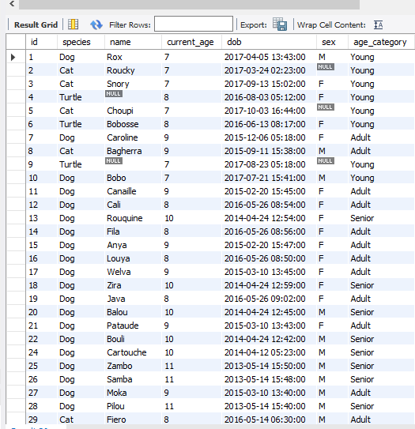

Q4.

What query would you run if your company wants to run an analysis on the country data of the world database to determine the size of the countries? They have asked you to create a query that categorizes countries based on the following criteria:

* + If a country has a population under 100,000, it is small.
  + If a country has a population between 100,000 and 500,000, it is medium.
  + In all other cases, the country is large.

